**Coding practice Problems:** 12.11.2024  
 **Name: VAITHIYANATHAN T   
 Dept :CSE**

**1. Anagram program :**

CODE:  
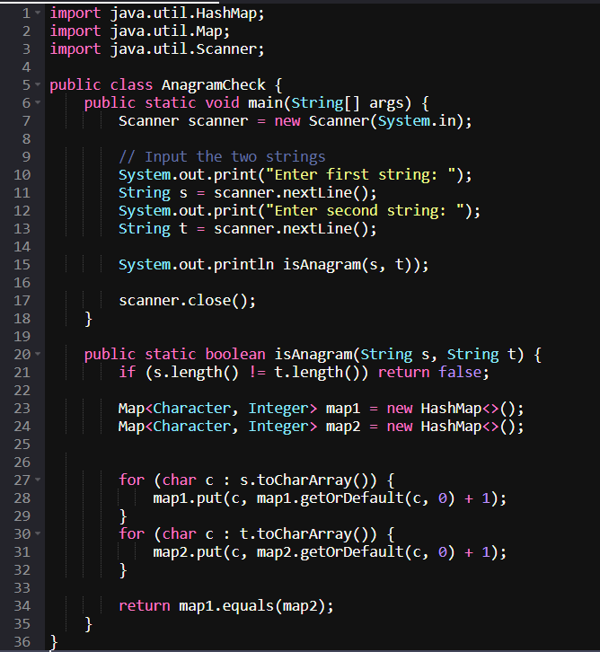

**OUTPUT** :

Enter first string: geeks

Enter second string: kseeg

True

**Time Complexity** : O(N)

**Space Complexity** : O(n)

2. Row with Max One’s

CODE:

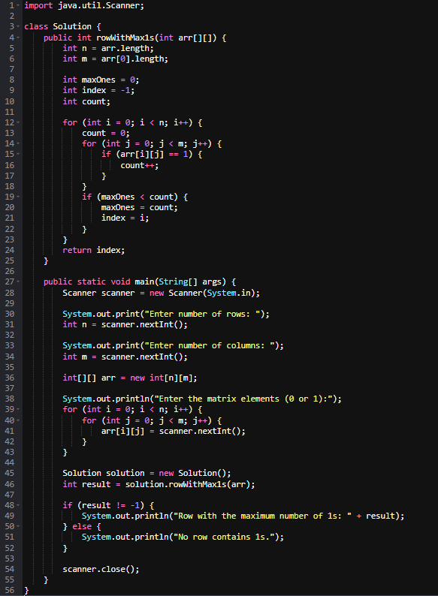Output:

Enter number of rows: 4 Enter number of columns: 5

Enter the matrix elements (0 or 1): 0 1 1 1 0 0 0 1 1 1 1 1 1 1 1 0 0 0 1 0

Row with the maximum number of 1s: 2

Time Complexity : O(n*m)

Space Complexity : O(1)

3. Longest consequtive subsequence

CODE:

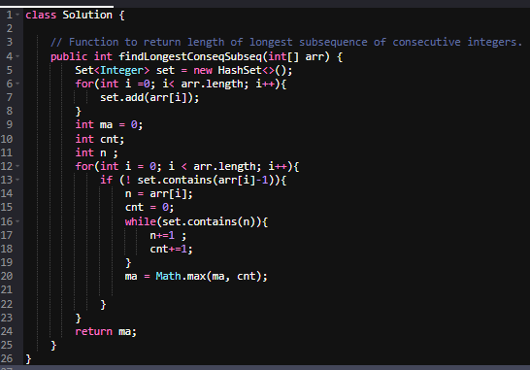Time Complexity : O(n)

Space Complexity: O(n)

5 . Longest Palindromic Substring

**CODE** :

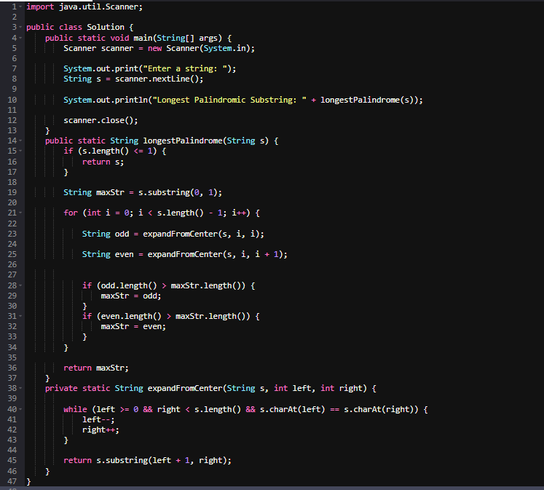

**OUTPUT**:

Enter a string: Geeks

Longest Palindromic Substring: ee

Time Complexity : O(n*2)

Space Complexity : O(1)

6. Rat in a Maze

CODE :

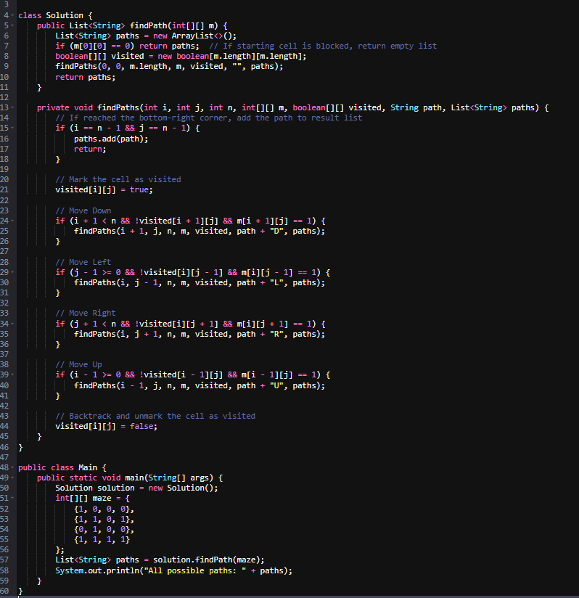

Output:

Time Complexity :**O(4^(m*n)**

Space Complexity: O(n*n)